DBMS Assignment #3

Ihor Holubets

10/21/25

Query #1:

This query is supposed to list the names of products that are no longer available where the sell.quantity_available is equal to zero. Since our output evidently has no names of products, therefore, there is no product that isn’t available. To make sure this is evidently our case we can check the quantity available for each product and since they are all one or more then all products are available.

Query #2:

This query involves products that are not sold.

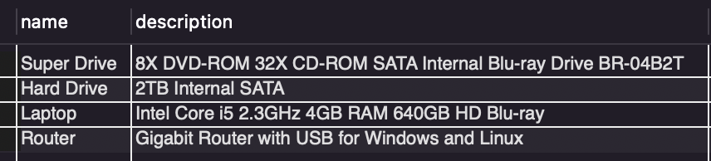

This query is supposed to list any products that do not appear in the sell table. A product appears in the sell table only if a merchant is selling it. The use of a LEFT JOIN with sell.pid IS NULL is checking which products have no matching sale records.

Query #3:

This query is checking how many customers bought a SATA “Hard Drive” but did **not** also buy a “Router.” It first finds all customers who purchased a hard drive, and then removes any customer who also purchased a router

The output was **2**, which means there are **two customers** in the database who purchased a hard drive but **never purchased a router**. Since they never appear in the subquery that checks for router purchases, they are included in the final count.

Query #4:

This query is supposed to apply a 20% discount to all products sold by the company **HP** that belong to the **Networking** category. It multiplies the current price by 0.8 (which represents a 20% reduction).



The output showed **0 rows affected**, which means there were no HP products in the Networking category in the current dataset. Since HP does not sell any networking products, there was nothing to update, so the discount could not be applied.

Query #5:

This query lists all products that were ordered by the customer **“Uriel Whitney”** and specifically purchased from the company **Acer**. It joins the customers, orders, products, and merchants tables to trace which items were bought and from which company.

The output shows the products and their prices that Uriel Whitney bought.

Query #6:

This query calculates the **total yearly sales for each merchant (company)**. It looks at all products that were sold, joins them to their orders, and then groups the results by both merchant and the year of the order. The sum(sell.price) function is used to add up how much money each company made in each year.

Query #7:

This query finds **which merchant (company) earned the highest total sales in a single year**. It uses the same logic from the previous query to total the yearly sales, but then sorts the results from highest to lowest and only keeps the top one using limit 1.

The output shows **one year** the company that made the most revenue during that year. This means that out of all companies and all years in the dataset, this company had the highest total dollar sales.

Query #8:

This query calculates the **average cost of shipping** by using the avg(orders.shipping_cost) function. It looks at all shipping records in the orders table and computes the overall average shipping price.

The result shows a **single number**, which represents the **average shipping cost across all orders** in the database. This helps us understand roughly how much customers pay on average for shipping.

Query #9:

This query calculates how much sales each company earns from each product category. It multiplies price × quantity available to estimate the revenue for that category, and then groups the results by merchant and product category.

The results show each company followed by a category (Peripheral, Networking, or Computer) and the total money earned from that category. From the output, it is evident that for **every company**, the category with the highest total sales value is **Peripheral**, which means these products are the best-selling category across all companies.

Query #10:

This query shows how much each customer spent at each company by summing their purchases. The output shows the company name, customer name, and total spent. Since each customer only made one purchase per company, the totals are the same, so the highest and lowest spenders look equal in this dataset.